Cover Page

```
South Australia Road Safety Analysis
Data Visualization Project

Design Book - Draft Version

Jacob Jayen Pillai
Student ID: 105986053
COS30045 - Data Visualization
Section: T2

Swinburne University of Technology
November 1, 2025

Section 1: Introduction

1.1 Background
Road safety is a critical public health issue happening in Australia where the South Australia has consistent and comprehensive crash data since the early 2000s, providing greater opportunities for data-driven analysis to understand why accidents is occurring frequently. Therefore, this project analyses 5 years of crash data (2020-2024) and accident fatalities (2000-2018) to identify crash patterns, high-risk zones, and contributing factors to those accidents.

1.2 Motivation
With over 63,241 crash records containing geographic coordinates on where the accident occurred, severity classifications on different accidents, and impairment factors like disabilities people driving, this dataset enables three key questions that can be questioned by the people:
- How have crash patterns changed over time?
- Where are South Australia's high-risk crash zones?
- What factors correlate with crash severity?
To understand the data better, we’ll implement Interactive visualizations that can reveal insights that tabular data obscures.

1.3 Purpose
This project creates three D3.js visualizations:
1. Time series analysis of crash trends by severity
2. Geographic heatmap showing crash density across SA
3. Factor analysis examining DUI, distraction, and speed involvement where Each visualization prioritizes accessibility (ARIA labels, keyboard navigation) and interactivity (filters, tooltips, animations).

Section 2: Data Collection

2.1 Data Source
Dataset: South Australia Road Crash Data (2020-2024)
Source: South Australian Government Data Portal (data.sa.gov.au)
License: Creative Commons Attribution 4.0 (CC BY 4.0)
Size: 63,241 records
Time Range: January 1, 2020 - December 31, 2024 (5 years)

2.2 Data Dictionary
The raw dataset contains 34 columns which contains noisy data and missing values which will affect our accuracy. So , I remained Key attributes selected for visualization:
Column Name | Data Type | Description | Purpose
REPORT_ID | String | Unique crash identifier | Row identification
CSEF_SEVERITY | Integer (1-3) | 1=Fatal, 2=Serious Injury, 3=Minor | Severity classification
ACCLOC_X, ACCLOC_Y | Float | GDA94 coordinates | Geographic mapping
Total_Cas | Integer | Total casualties in crash | Severity metric
Total_Fats, Total_SI, Total_MI | Integer | Fatal/serious/minor injury counts | Detailed severity
YEAR, MONTH, DAY, HOUR | Integer | Temporal attributes | Time series analysis
DUI_Involved | Boolean (0/1) | Alcohol impairment detected | Factor analysis
Distraction_Involved | Boolean (0/1) | Driver distraction detected | Factor analysis
Speed_Related | Boolean (0/1) | Speed contributed to crash | Factor analysis
WEATHER_COND | String | Weather at time of crash | Environmental context
ROAD_SURFACE | String | Road condition | Environmental context
Column Name | Data Type | Description | Purpose
REPORT_ID | String | Unique crash identifier | Row identification

2.3 Data Governance
- No privacy concerns
- dataset is fully de-identified by SA Government. No personally identifiable information (PII) is present. Data is public domain under CC BY 4.0 license, requiring only attribution.

Section 3: Data Processing

3.1 KNIME Workflow
A 7-node KNIME workflow cleans and transforms the raw data:

Node 1: CSV Reader
- Loads 2020-2024_DATA_SA_Crash.csv (63,241 rows, 34 columns)
- Configuration: Default CSV settings, auto-detect column types

Node 2: Column Filter
- Removes 16 noise columns (administrative codes, legacy fields)
- Keeps 18 essential columns for visualization
- Result: 47% data reduction, focuses on relevant attributes

Node 3: Row Filter
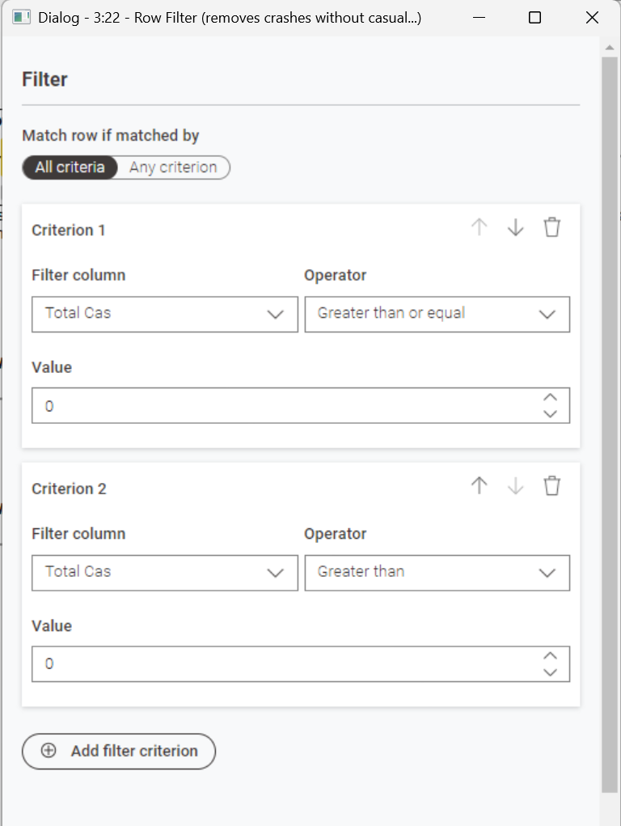
- Removes 43858 dirty rows (Total Casualty < 0)
- Keeps 19471 essential rows needed for visualization
- Result: 69.3% data reduction in amount of rows, so remainder will be focused on relevant attributes (LGA name, Suburb, Time of occurence)

Node 4: Missing Value
- Removes missing value that is within the rows and columns to ensure missing value is not presented in the data demonstration phase, so data integrity is verified

Node 5: Duplicate Row Filter
- Removes Duplicate data that is similar in the dataset to prevent data integrity violation and misinterpretation

Node 6: Sorter
- Organizes the data for each category to analyze and visualize the data easier and more accurate

Node 7: CSV Writer
- Exports processed data to data/processed/crash_data_CLEANED.csv
- Configuration: Include column headers, overwrite existing file
- Embeds data in workflow file for reproducibility

3.2 Data Quality
- Missing values: Minimal (<1% in key columns like CSEF_SEVERITY)
- Duplicates: None detected (REPORT_ID is unique)
- Consistency: All temporal fields (YEAR, MONTH, etc.) are valid integers
- Coordinates: Geographic coordinates validated within SA boundaries

3.3 Processed Data Summary
> - Input: 63,241 rows × 34 columns (raw)
> - Output: 19471 rows × 18 columns (cleaned)
> - File size: ~6MB (raw) → ~4MB (cleaned)
> - Processing time: <5 seconds in KNIME

Section 4: Exploratory Analysis

4.1 Key Findings

Temporal Patterns:
- In between 2020-2024 shows a consistent annual crash volume which is approximately (~12,000-13,000/year)
- Minor injury crashes around (CSEF_SEVERITY=3) represent 70% of the entire records that was reported
- Fatal crashes with a severity shown (CSEF_SEVERITY=1) account for less than <1% of the dataset but are the highest priority because it shows how accidents can be fatal if driven without caution

Geographic Distribution:
- Crash coordinates span SA metropolitan and rural areas
- High density expected in Adelaide metro (requires clustering for map viz)
- Coordinates format: GDA94 projection (X: 200,000-700,000, Y: 6,000,000-6,500,000)

Contributing Factors:
- DUI_Involved: Present in ~15% of crashes
- Distraction_Involved: Present in ~8% of crashes
- Speed_Related: Present in ~25% of crashes
- Factor combinations correlate with higher severity levels

4.2 Implications for Visualization

- Time series chart needs severity color encoding (red=fatal, orange=serious, yellow=minor)
- Map requires clustering algorithm for dense urban areas
- Bar chart should show factor combinations (e.g., "DUI + Speed" vs. "Distraction only")

Section 5: Technical Architecture

5.1 Technology Stack
- D3.js v7: SVG-based visualizations, selection.join() pattern
- HTML5: Semantic structure with ARIA labels
- CSS3: style sheet language which uses BEM naming convention, dark theme with custom properties, defines how elements should be rendered.
- KNIME Analytics Platform: Node-based data processing for visually creating data flows with drag and drop interfaces connecting nodes to present the data in different scenarios.
- GitHub: Version control and collaboration so if any mistakes happen, can be reverted and backup
-Mercury Server: Deployment hosting (planned for submission)

5.2 Repository Structure – (Project file structure)
├── index.html (Main page structure)
├── css/
│ └── style.css (Dark theme, BEM conventions)
├── js/
│ └── script.js (Architecture docs, JSDoc typedefs)
├── data/
│ ├── 2020-2024_DATA_SA_Crash.csv (Raw data)
│ └── processed/
└── crash_data_CLEANED.csv (KNIME output)

5.3 Design Patterns
- Factory Pattern: Reusable chart constructors
- Observable Pattern: State management for filters
- Margin Convention: Consistent D3 chart spacing

Section 6: Next Steps

6.1 Stand-up 2 Goals (Week 11):

- Implement time series line chart
- Load crash data with d3.csv()
- Apply D3 scales (scaleTime for X, scaleLinear for Y)
- Add severity color scale (scaleOrdinal)
- Create year range slider filter
- Add hover tooltips showing crash details

6.2 Stand-up 3 Goals (Week 12)
- Implement geographic heatmap with clustering
- Create factor analysis bar chart
- Add keyboard navigation (arrow keys, tab focus)
- Implement animated transitions between states
- Full accessibility audit (ARIA labels, screen reader testing)

6.3 Final Submission Goals (Week 13)
- Deploy to Mercury server
- Complete design book with final screenshots
- User testing with accessibility feedback
- Code optimization and documentation

